Report on Consumption in the United States
Student Name Here
Institution

Report on Consumption in the United States

Introduction
This research paper aimed at determining the distribution of annual food spending, annual household income, non-mortgage household debt by geographic regions of the United States (U.S.) and household location. Based on this study, four geographic regions of the U.S. namely; the Northeast, the Midwest, South, and the West region was under consideration while the classification of households by location was into two categories, either in a metro area and those households outside metro areas. Data analysis was carried out using excel.

Objectives of the study
- To determine if the average annual food spending for a household in the Midwest region of the U.S. is more than $8,000.
- To determine if there is a significant difference between households in a metro area and households outside metro areas in annual food spending.
- To determine if there is a significant difference between Annual Food Spending, Annual Household Income, Non-Mortgage Household Debt in the four Geographic Region of the U.S.

Research Questions
- How does the average annual food spending for a household in the Midwest region of the U.S. differ from $8,000?
- How does the annual food spending amongst households in a metro area and households outside metro areas differ?
- How do the annual food spending, annual household income, and non-mortgage household debt differ in the four geographic regions of the U.S.?

Population and the sample size
The population of the study consisted of all data on annual food spending per Household, annual household income, the non-mortgage household debt of all households in the U.S. by their Geographic Region and Household Location. A random sample of 200 households was drawn from the population to be used in various statistical analysis and hence making inferences from the research findings.

Variables, Type of Data and Level of Measurement
The variables Annual Food Spending per Household, Annual Household Income and Non-Mortgage Household Debt are all continuous variables hence have quantitative data whose level of measurement is scale. Both Geographic Region in the U.S. and Household Location in the U.S. are categorical variables thus have qualitative data whose level of measurement is Nominal. Households are divided into four Geographic Region namely; the Northeast, the Midwest, South, and the West. Further households are divided into two categories by location, either in a metro area and those households outside metro areas.

Descriptive Statistics
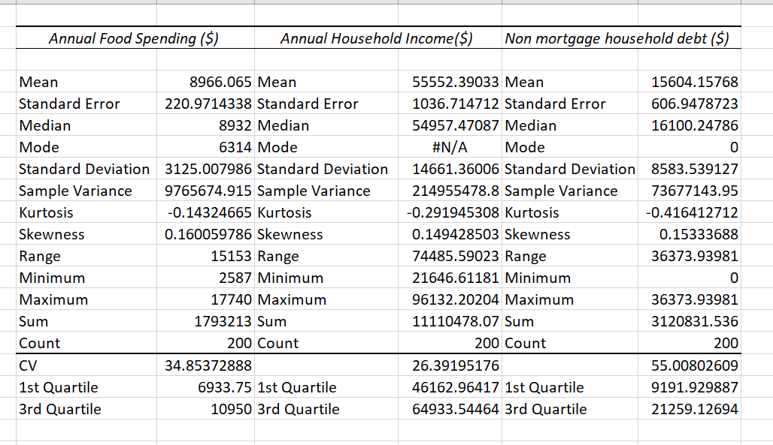
From table 1, the mean, median and the mode annual food spending is $9866.07, $8932 and $6314 respectively. The range of annual food spending is $15153. Its standard deviation and variance are $3125.01 and $9765674.92. The coefficient of variation (CV) is 34.85 %. The five-summary statistics consisting of the minimum, 1st quartile, median, 3rd quartile, and the maximum annual food spending are $2,587, $6,933.75, $8,932, $10,950 and $17,740 respectively.
On the other hand, the mean Annual Household Income was found to be $55,552.39. The range of Annual Household Income is $74,485.59. Its standard deviation and variance are $14,661.36 and $214,955,478.80. The coefficient of variation (CV) is 26.39 %. The five-summary statistics consisting of the minimum, 1st quartile, median, 3rd quartile and the maximum annual household income are $21,646.61, $46,162.96, $54,957.47, $64,933.54 and $96,132.20 respectively. While the mean non-mortgage household debt was found to be $55,552.39. The range of Annual Household Income is $74,485.59. Its standard deviation and variance are $14,661.36 and $214,955,478.80. The coefficient of variation (CV) is 26.39 %. The five-summary statistics consisting of the minimum, 1st quartile, median, 3rd quartile and the maximum non-mortgage household debt are $21,646.61, $46,162.96, $54,957.47, $64,933.54 and $96,132.20 respectively.

Outliers are values which are overly small or large as compared to the rest of the values.
Figure 1 above shows that presence of outliers in the on Annual Food Spending per Household, Annual Household Income data which are their respective maximum values of $17,740 and $96,132.20. No outlier is present in the non-mortgage household debt series.

Inferential Statistics

Hypotheses 1
Null hypothesis: The average annual food spending for a household in the Midwest region of the U.S. is less or equal to $8,000.
Alternative hypothesis: The average annual food spending for a household in the Midwest region of the U.S. is more than $8,000.

Results and Discussion
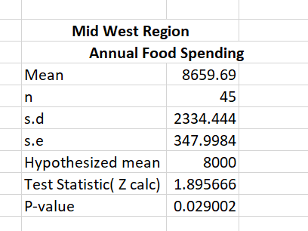
From table 2 above, the one-tailed test statistic (Z_{calc}) is 1.8957. Since the p-value associated with this test statistic is 0.029002 which is greater than the significance level of 0.01, the null hypothesis will therefore not be rejected leading to the conclusion that the average annual food spending for a household in the Midwest region of the U.S. is not statistically significantly more than $8,000 at a 1% significance level.

Hypotheses 2
Null hypothesis: There is no statistically significant difference between annual food spending amongst households in a metro area and households outside metro areas.
Alternative hypothesis: There is a statistically significant difference between annual food spending amongst households in a metropolitan area and households outside metropolitan areas.

Results and Discussion
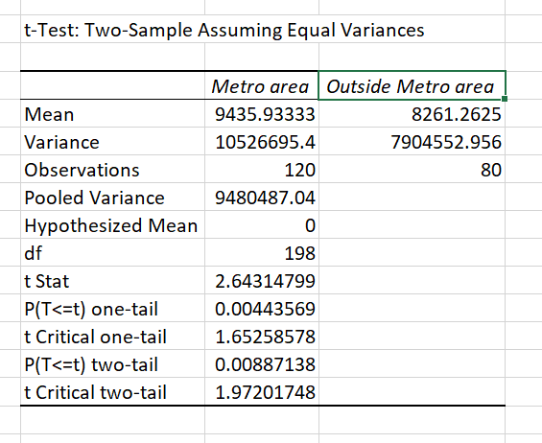
From table 3 above, the two-tailed test statistic (Z_{calc}) is 2.64315. Since the p-value associated with this test statistic is 0.00887 which is less than the significance level of 0.01, the null hypothesis will, therefore, be rejected leading to the conclusion that there is a statistically significant difference between annual food spending amongst households in a metro area and households outside metro areas at 1% level of significance. Average annual food spending amongst households in a metropolitan area is $9,435.93 which is significantly greater than the mean annual food spending amongst households outside metropolitan areas of $8,261.26.

Hypotheses 3
Null hypothesis: There is no statistically significant difference between annual food spending in the four geographic regions of the U.S.
Alternative hypothesis: There is a statistically significant difference between annual food spending in the four geographic regions of the U.S.

Results and Discussion
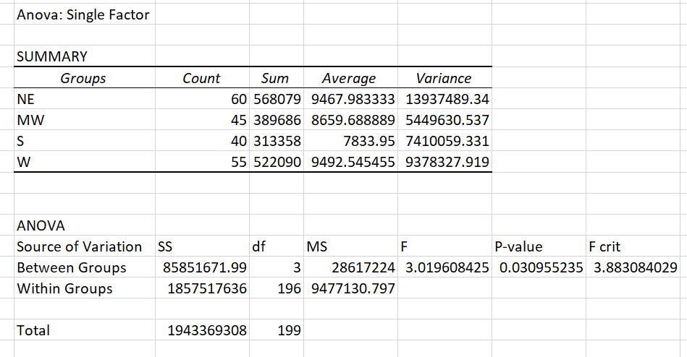

From table 4 above, the F statistic is 3.0196, and its associated p-value is 0.030955 which is greater than the significance level of 0.01. The null hypothesis will, therefore, be accepted leading to the conclusion that there is no statistically significant difference between annual food spending in the four geographic regions of the U.S. at a 1% level of significance. On average, annual food spending in four regions in the U.S. was found to be $9,435.93 in Northeast, $8,659.69 in Midwest, $7,833.95 in South and $9,492.55 in the West. However, these variations are not statistically significant at a 1% significance level.

Hypotheses 4
Null hypothesis: There is no statistically significant difference between annual household income in the four geographic regions of the U.S.
Alternative hypothesis: There is a statistically significant difference between annual household income in the four geographic regions of the U.S.

Results and Discussion
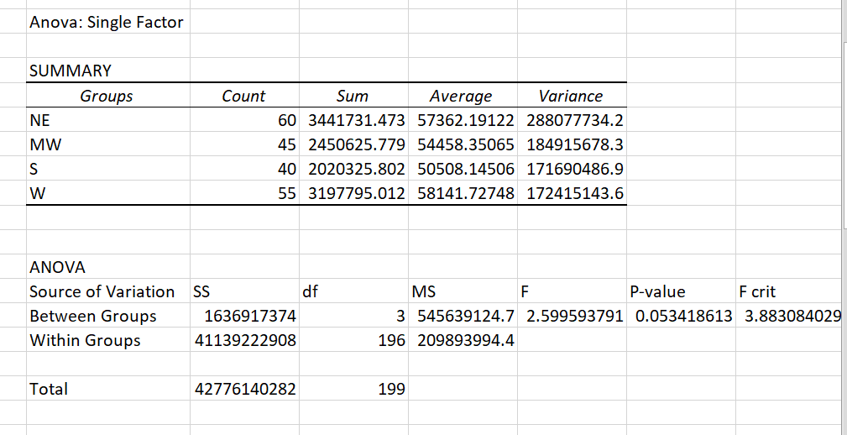
From table 5 above, the F statistic is 2.5996, and its associated p-value is 0.05342 which is greater than the significance level of 0.01. The null hypothesis will, therefore, be accepted leading to the conclusion that there is no statistically significant difference between annual household income in the four geographic regions of the U.S. at 1% significance level. On average, annual household income in the four regions in the U.S. was found to be $57,362.19 in Northeast, $54,458.35 in Midwest, $50,508.15 in South and $58,141.15 in West region of U.S. However, these variations are not statistically significant at 1% significance level.

Hypotheses 5
Null hypothesis: There is no statistically significant difference between non-mortgage household debt in the four geographic regions of the U.S.
Alternative hypothesis: There is a statistically significant difference between non-mortgage household debt in the four geographic regions of the U.S.

Results and Discussion
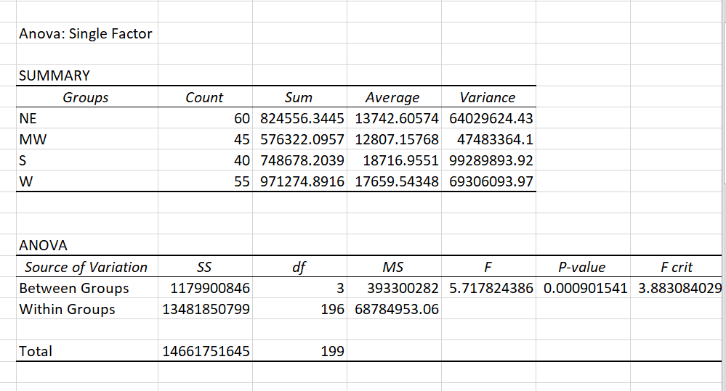
From table 6, the F statistic is 5.7178, and its associated p-value is 0.0009 which is less than the significance level of 0.01. The null hypothesis will, therefore, be rejected leading to the conclusion that there is a statistically significant difference between non-mortgage household debt in the four geographic regions of the U.S. at a 1% level of significance. On average, non-mortgage household debt in four regions in the U.S. was found to be $13,742.61 in Northeast, $12,807.16 in Midwest, $18,716.9551 in South and $17,659.54 in West region of U.S. These variations are statistically significant at 1% level of significance.

Conclusion and recommendations
Based on the first objective, the study findings indicated that the average annual food spending for a household in the Midwest region of the U.S. was found not be statistically significantly more than $8,000 at 1% level of significance. Secondly, annual food spending amongst households in a metropolitan area and households outside metropolitan areas were found to be statistically significantly different at 1% significance level. Average annual food spending amongst households in a metropolitan area is $9,435.93 which is statistically significantly more significant than the mean annual food spending amongst households outside metropolitan areas of $8,261.26. Thus food producing companies should focus on increasing food consumption levels in areas outside through means such as marketing and also increasing their products supplies. High consumer spending in metropolitan areas is indicative of higher market demand, and thus new investors on food staffs should take advantage of higher market demand in these areas.
Based on the third objective, the findings indicated that average annual food spending and annual household income did not statistically significantly differ across the four geographic regions of the U.S. However, non-mortgage household debt in the four geographic regions of the U.S. was found to differ significantly at 1% level of significance. On average, non-mortgage household debt in four regions in the U.S. was found to be $13,742.61 in Northeast, $12,807.16 in Midwest, $18,716.9551 in South and $17,659.54 in West region of U.S. Thus lenders should consider geographical regions as a risk factor when issuing loans to their customers. Midwest was found to have a higher non-mortgage household debt level while Northeast has the lowest level.
Including age composition across the regions to allow analysis by age might lead to a different conclusion since consumption and income levels depend on age.

References
Davis, C., & McQuestion, J. (2017). Bayesian Inferential Statistics Implemented in R.
George, D., & Mallery, P. (2016). Descriptive statistics. In IBM SPSS Statistics 23 Step by Step (pp. 126-134). Routledge.
Holcomb, Z. C. (2016). Fundamentals of descriptive statistics. Routledge.

